A Proposal for

Prisoner

A Video Game

Prepared for

Evan Wells, Co-President of Naughty Dog Studios, Santa Monica, CA

Submitted by

Dillon Wertman

December 1, 2016

177 Totem Drive

Auburn, PA 17922

November 20, 2016

Evan Wells

Co-President

Naughty Dog Studios

2425 Olympic Blvd #3000w

Santa Monica, CA 90404

Dear Mr. Evan Wells:

This is a proposal requesting the production of a new video game. Entitled “Prisoner” it is designed to be a powerful storytelling experience for PC and console gamers. Since the market is saturated with multiplayer games and underwhelming single player experiences, a well-developed single player experience could quickly become a best seller.

Prisoner will feature in depth storytelling through everything from graphics to gameplay. It will touch upon philosophic concepts like crime, punishment, and innocence. The game will also feature a host of popular action role playing elements like real time combat, deep and consequential dialogue and much more.

Enclosed for your review is my proposal. Please feel free to contact me at 570 640 8807 and I will be happy to provide additional information and answer any queries. Thank you for your time and consideration.

Sincerely,

Dillon Wertman

Dillon Wertman

Enclosure

## **Table of Contents**

1. Introduction 6
   1. Purpose 6
   2. Needs Analysis 6
2. Discussion 7
   1. Overview 7
   2. Plot 7
   3. Setting 7
   4. Benjamin Perdix 8
   5. The Warden 10
   6. Other Characters 11
   7. Gameplay 12
   8. Graphics 12
   9. Staffing 12
   10. Music/Sound 15
   11. Equipment 16
   12. Marketing 17
   13. Cost 19
3. Conclusion 20
   1. Summary 20
   2. Recommendations 20

Glossary 21

Works Cited 22

Appendix A 27

Appendix B 29

## **List of Illustrations**

**Figure 1** Setting 8

**Figure 2** Prison 8

**Figure 3** Cell 8

**Figure 4** Cloud 9

**Figure 5** Hwoarang 9

**Figure 6** Focus Senses 10

**Figure 7** X-Ray Vision 10

**Figure 8** Warden Appearance 10

**Figure 9** Mask 10

**Figure 10** Alex Vance 11

**Figure 11** Elena Fisher 11

**Figure 12** Gritty 12

**Figure 13** Dark 12

**Figure 14** Zelda Chest 16

**Figure 15** Dark Souls Area 16

**Figure 16** Hardware Requirements 16

**Figure 17** Software Requirements 17

**Figure18** Statistics 18

**Figure 19** Social Networking 19

**Figure 20** Salaries 19

**Figure A1** Burvingwald Penitentiary 27

**Figure A2** Benjamin’s Cell 27

**Figure A3** Prison Area 28

**Figure B1** Hierarchy 29

**Figure B2** Lower Positions 30

# 1.0 Introduction

**1.1 Purpose**

This is a proposal to start development on a new video game titled “Prisoner”. My goal is to lay down suggestions and give an idea of a direction I would like to see this video game to take, however much of the development will be left up to the developers. This game will emphasize the single-player experience and won’t include a multiplayer feature.

**1.2 Needs Analysis**

### 1.2.1 Under a Stigma

“When you see somebody playing RPGs in a movie, he’s probably not going to be the cool kid—in fact, he’s probably going to be a cliché nerd hacker with very few redeemable qualities.” (Schreier). Enjoying the hobby of video games comes with a rather unwanted secondary price tag: the stigma of being an antisocial shut-in. There isn’t just a stigma against the people who play video games, because there seems to be an outlash against each new video game that involves even a hint of violence, as well as a fear that the next real-world act of aggression will be caused and fueled by the virtual realm. “Critics argue that these games desensitize players to violence, reward players for simulating violence, and teach children that violence is an acceptable way to resolve conflicts.” (“Videogames”).

### 1.2.2 Unfulfilled Expectations

Shakti Gawain once said “Ambition is an idol, on whose wings great minds are carried only to extreme; to be sublimely great or to be nothing.” (“Shakti”). In recent years, it seems that game developers promise grandiose game experiences, but fail to deliver on that promise. A most recent example of this would be “No Man’s Sky” by Hello Games. “Both Sony and Hello Games have been strangely silent in the wake of the game’s launch… not addressing many of its most discussed issues, namely a laundry list of features that ended up being cut from the game, with players feeling misled as a result.” (Tassi). Developers often promise the moon, but fail to even deliver the stars.

### 1.2.3 Casual vs Competitive

No doubt, competitive video games are becoming a world-wide phenomenon. “More than 70 million people worldwide watch e-sports over the Internet or on TVs…” (Wingfield). Indeed, there seems to be a total neglect over the past few years of the single player experience. “For the most part, the focus on a strong multiplayer is so great, that developers often forget that the single player experience needs to be just as strong...” (Castro-Reyes).

# 2.0 Discussion

**2.1 Overview**

Prisoner will be a single-player* role-playing video game* taking advantage of modern computing technology to offer a truly immersive and enjoyable virtual storytelling experience. The game will touch on philosophic concepts of crime, punishment, innocence, and redemption all while having a player control the actions and decisions of the main character, Benjamin Perdix.

**2.2 Plot**

2.2.1 Plot Overview

The story follows Benjamin Perdix in his seemingly futile attempt to escape Burvingwald Penitentiary, a maximum-security prison. While the player navigates through the labyrinthine prison, more is revealed about Benjamin’s past through flashbacks and conversation. Using Benjamin Perdix’s special abilities, the player can access secret areas of the prison to find out more about the world outside the prison

2.2.2 Exposition

The game begins with a sullen and pitiful view of Benjamin Perdix in restraints designed especially for him. Through flashbacks or conversation amongst the guards, it is revealed that Benjamin awaits execution as a death row inmate. Cecilia Griffith and Dr. Archibald Ceres enter the room, as is their routine. However, this time is different, for after Cecilia performs basic medical checkups, she slips a key into Benjamin’s restraints and unlocks them, setting Benjamin free. Benjamin makes quick work of the guards stationed in his room, then makes for the exit to his room.

2.2.3 Climax

Benjamin will come across the main antagonist, The Warden, quite often as the player traverses the prison. However, there will be a final, climatic battle between the two near the end of the game. Upon his defeat, The Warden will disclose his dream to Benjamin, how he became who he was, and what he wanted to truly accomplish with the prison. After hearing his monologue, the player will be able to finally make it towards the exit.

2.2.4 Resolution

The game ends with an uplifting and joyful view of Benjamin exiting the prison. The feeling Benjamin experiences of freedom after being held for so long is translated to the player, and he or she too might feel a sense of having overcome a nearly impossible situation. As Benjamin Perdix steps outside the entrance, the credits begin to roll.

**2.3 Setting**

The game takes place in a maximum-security prison. However, there is an entire world outside of the prison. The setting blends sci-fi and fantasy, much like Marvel’s “Thor”. See Figure 1 below.

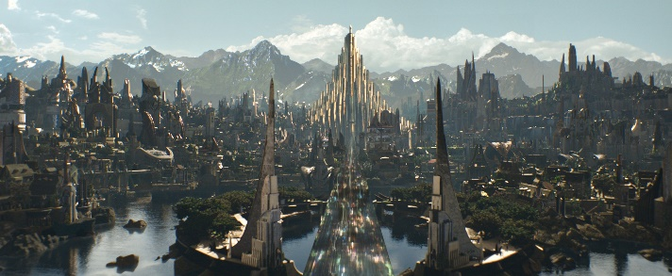

**Figure 1.** Setting. (“Asgard”).

2.3.1 Oberon

Oberon is a world where technology and magic coincide in blissful harmony. The inhabitants of this world use magic to enhance their technology and use their technology to gain further understanding of magic. Recently, the magic in the world has become unstable and permeates throughout nature. The most surprising affects have been the manifestation of supernatural abilities in humans and animals.

2.3.2 The Kingdom of Burvingwald

Much of the land in Oberon is ruled by kings. Burvingwald is the most prominent monarchy and the greatest superpower in the world. To keep crime in its cities low, the king of Burvingwald decreed to send all criminals to the largest mountain in the realm, Sequester’s Mountain. With this decree came a peace that none of the other kingdoms has experienced.

2.3.3 Burvingwald Penitentiary

Burvingwald Penitentiary is built into a mountain and is a labyrinth of pathways and cells. As one moves up the mountain, the severity of the prison sentence increases. The lower portions of the mountain are for misdemeanors and the upper portions are for felonies. There is an area reserved at the very top of the mountain for death row inmates. Figures 2 and 3 below show that the prison’s appearance borrows heavily from science fiction as it is a technological feat of maximum security. See Appendix A on page 26 for a simple layout of the prison, Benjamin Perdix’s cell, and what a typical area in the prison might look like.

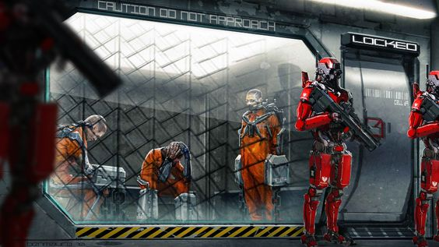

**Figure 2.** Prison. (Plunkett).

**Figure 3.** Cell. (“Sci-Fi Prison”).

**2.4 Benjamin Perdix**

2.4.1 Appearance

Benjamin Perdix is only a young adult as the game begins. He’s in his very late teens and has a rebellious or renegade look about him. His physical appearance resembles the likes of Cloud Strife from the Final Fantasy Series and Hwoarang from Tekken. See Figures 5 and 6 on page 9.



**Figure 4.** Cloud. (“Cloud Strife”).

**Figure 5.** Hwoarang. (“Hwoarang”).

2.4.2 Personality

Although labeled a perpetual criminal, he has somehow managed to retain a cheerful and happy-go-lucky attitude that only painted him as more of a delinquent when he ends up in trouble. At the beginning of the game, as the date of his execution rears its head, he begins to lose hope.

2.4.3 Background

Benjamin Perdix possesses a line of supernatural abilities that often put him in the spotlight of law enforcement. Benjamin Perdix’s past is riddled with situations that belie his attitude toward the world around him and his actions performed in the world. Benjamin’s past can be summed up as a story of “at the wrong place at the wrong time”.

2.4.4 In the Story

Through many discrepancies and questionable circumstances, Benjamin Perdix finds himself imprisoned in the most secure prison in Oberon, Burvingwald Penitentiary. For once in his life however, fortune smiles upon him as a doctor-in-training offers him the choice of freedom and thus begins his escape from the prison at the beginning of the game.

2.4.5 Gameplay

Benjamin Perdix is equipped with a suite of a superhuman abilities:

* Rapid regeneration
* Unmatched speed
* Unrivaled strength
* The player will be able to focus Benjamin Perdix’s senses to identify incoming threats, much like in the Assassin Creed and Batman series. See Figures 7 and 8 on page 10.

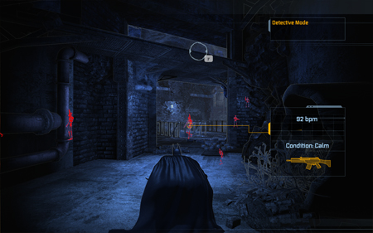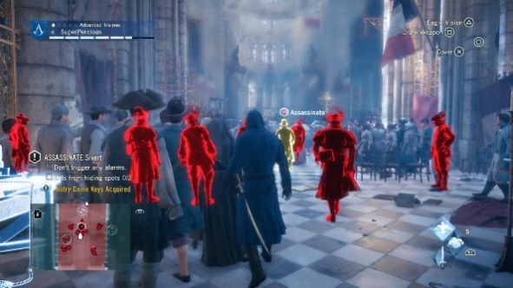

**Figure 6.** Focus Senses. (Purslow).

**Figure 7.** X-Ray Vision. (“Batman”).

However, Benjamin Perdix’s abilities will be handicapped at the beginning as they have atrophied during his time in solitary confinement. As the player moves through the prison and defeats The Warden’s officers he or she will be able to improve Benjamin Perdix’s abilities.

**2.5 The Warden**

2.5.1 Appearance

The Warden is a hulking figure: standing nearly 7 and a half feet tall and boasting large physical mass. He is clad in a suit of black armor that does little to hinder his movement. A tribal-esque helm adorns his head, making the Warden even more unnerving. His design reflects that of Ganondorf from the Legend of Zelda series, while the mask is reminiscent of the dragon priest masks in Bethesda’s “The Elder Scrolls V Skyrim”. See Figures 9 and 10 below.

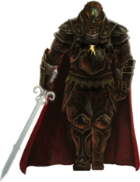

**Figure 9.** Mask. (“Skyrim”).

**Figure 8.** Warden Appearance. (“Ganon”).

2.5.2 Personality

The Warden holds himself to a high standard of justice. Although he does not hold back when delivering judgement, he does refrain from doing anything outside of the realm of justice to his prisoners: the punishment dealt out is necessary and proper.

2.5.3 Background

The Warden’s supernatural ability can dampen the effects of other supernatural abilities near him. He overcame many great feats to be placed as head enforcer of Burvingwald Penitentiary and carries out his duties there in a frighteningly efficient manner.

2.5.4 In the Story

The Warden does not tolerate disruptions in his prison. Although he lets minor bouts and scuffles slide, confrontations verging on the edge of riots are dealt by him personally. The Warden boasts great physical prowess and deals with his opponents in hand-to-hand combat. He also possesses the special ability to heavily dampen the effects of other supernatural abilities, which are found in quite a few of the inmates.

2.7.1 Gameplay

As the player moves through the prison, he or she is going to attract a lot of attention from guards. If the player causes enough of a disturbance, The Warden will act and try to stop the player from progressing. The player will not be able to best the warden in close combat, as the warden can nullify abilities. The only option will be to flee and wait for the warden to give up his search by hiding. Alternatively, the player can get away from The Warden if another disturbance arises that captures the Warden’s attention.

**2.6 Other Characters**

2.6.1 Cecilia Griffith

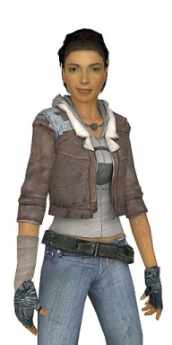Tactful, sharp, and eager to learn, Cecilia Griffith aids Dr. Archibald Ceres in performing medical checkups on Benjamin Perdix while also studying his mental state as a death row inmate for her doctorate thesis. However, she takes pity on Benjamin as she learns they are the same age but in radically different circumstances and thus orchestrates his release behind the scenes. Her appearance can be likened to Alex Vance from Half-Life 2 and Elena Fisher from Uncharted, see Figures 11 and 12 below.

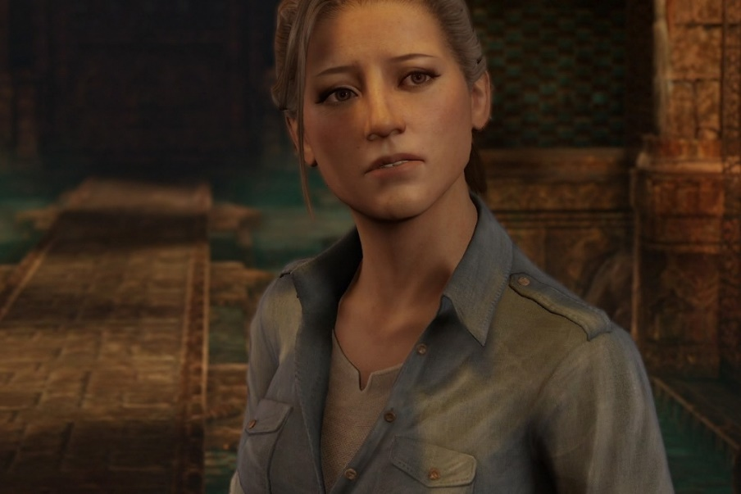

**Figure 11.** Elena Fisher. (Stewart-Seume).

**Figure 10.** Alex Vance. (“Alyx”).

2.6.2 Dr. Archibald Ceres

Dr. Archibald Ceres’ character borrows heavily from the mad scientist archetype. Although not totally lost to insanity, his drive for experimentation and results makes him a loose cannon. In addition to being a prominent scientist in Burvingwald, he is also a medical doctor that found a way to extract supernatural abilities from their human vessels. Dr. Ceres is hired by the prison to oversee and study the inmates with supernatural abilities and mentors his eager pupil, Cecilia Griffith.

2.6.3 Orion Gerdhart, King of Burvingwald

Orion Gerdhart conceived the idea of Burvingwald Penitentiary to reduce crime in his kingdom and bring peace to his realm. With the criminals located elsewhere, attention could be taken away from law enforcement and focused on domestic policies to increase the kingdom’s wealth. The king rules over a land in a state of near utopia, mostly due to the creation of this prison.

**2.7 Gameplay**

2.7.1 Action

Combat will be carried out in real time as compared to turn-based: one press of a button will immediately trigger an action from Benjamin Perdix. The player will be able to string together a multitude of combinations that incorporate Benjamin’s various abilities.

2.7.2 Traversing the Prison

Although sneaking around would be a favorable tactic in a situation that demands the player to remain undetected, it has never been Benjamin Perdix’s advantage. There will be an option to move stealthily, but there will be times where that is impossible. The goal in these situations is to defeat the guards quickly enough to avoid raising too much attention.

2.7.3 Dialogue

In the rare situations that Benjamin has time to catch his breath he will be able to talk to other inmates and characters. Selecting certain phrases to certain people at certain times will lead to many possible outcomes: revealing weaknesses in enemies; gleaning knowledge of the outside world; learning about other prominent characters; etc.

**2.8 Graphics**

To enhance the gritty and dark atmosphere of the prison moody lighting and similar techniques should be used to further immerse the player in the world. As a reference, From Software’s “Dark Souls” and Rocksteady Studio’s “Batman” series feature gritty filters and dark aesthetics. See Figures 13 and 14 below.

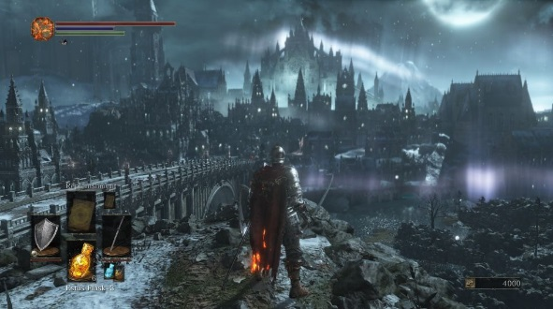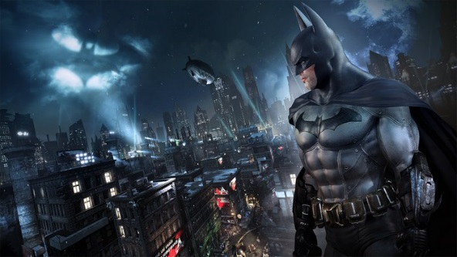

**Figure 12.** Gritty. (Makuch).

**Figure 13.** Dark. (Strom).

**2.9 Staffing**

Behind every Video Game is an army of qualified people that put forth their various talents to produce a single awe-inspiring virtual adventure. For the sake of simplicity, I’ve outlined the major lead roles a company should possess to produce a high-quality game. These roles should oversee the hiring of lower positioned employees in their respective fields. The qualifications provided for the lead positions are a minimum recommendation. See Appendix B on page 29 for a chart of interactions between these positions and lower positions.

2.9.1 President

The president is responsible for providing strategic leadership for the company by working with the Board and other management to establish long-range goals, strategies, plans and policies. (“President”).

Qualifications and responsibilities:

* Bachelor’s degree.
* 8-10 years of related industry experience.
* Contracts and negotiation experience. (“Top Executives”)
* Plan, develop, organize, implement, direct and evaluate the organization's fiscal function and performance.
* Participate in the development of the corporation's plans and programs as a strategic partner.
* Evaluate and advise on the impact of long range planning, introduction of new programs/strategies and regulatory action.
* Evaluate the finance division structure and team plan for continual improvement of the efficiency and effectiveness of the group as well as providing individuals with professional and personal growth with emphasis on opportunities (where possible) of individuals. (“President”)

2.9.2 Chief Technical Officer

“The Chief Technology Officer (CTO) is responsible for overseeing all technical aspects of the company.  The CTO works with Executive Management to grow the company through the use of technological resources. Using an active and practical approach, the CTO will direct all employees in IT and IO departments to attain the company’s strategic goals established in the company’s strategic plan.” (“Chief”).

Qualifications and responsibilities:

* B.S. degree in related field
* 15 years of experience in IT field
* 10 years of management and strategic experience (“Computer and”).
* Establish the company’s technical vision and leads all aspects of the company’s technological development.
* Directs the company’s strategic direction, development and future growth.
* Works in a consultative fashion with other department heads, such as marketing, production and operations as an advisor of technologies that may improve their efficiency and effectiveness. (“Chief”).

2.9.3 Creative Director

The creative director produces instructional and visionary materials for staff and external clients. (“Managing”).

Qualifications and responsibilities:

* Bachelor’s degree in communications-related field.
* 5 years of experience writing video scripts for the training industry.
* One year of supervisory experience or an equivalent combination of education and experience.
* Researches, designs, and writes generic and contract video treatments and scripts.
* Works with executive producer to develop and close new business.
* Researches, designs, and writes post-project evaluations and case studies.
* Writes training support materials, such as facilitator guides and participant guides.
* Participates in meetings with producer, director, and client to critique scripts.
* Recruits, interviews, trains, disciplines, and evaluates employees. (“Managing”).

2.9.5 Art Director

Spearheads artistic development of all aspects of product and offers critic and suggestion for improvement on projects. (“Art Directors”).

Qualifications and responsibilities:

* Bachelor’s degree
* 5 years’ experience in art field
* 5 years’ experience in management field
* Determine how best to represent a concept visually
* Determine which photographs, art, or other design elements to use
* Develop the overall look or style of a publication, an advertising campaign, or a theater, television, or film set
* Lead graphic designers, set and exhibit designers, or other design staff
* Review and approve designs, artwork, photography, and graphics developed by other staff members
* Talk to clients to develop an artistic approach and style (“Art Directors”)

2.9.6 Audio Director/Audio Manager/Sound Producer

Supervises audio team in development of sound components in products. May be involved in production of music for the product as well. (“Broadcast”).

Qualifications and responsibilities:

* Bachelor’s degree in music industry
* 5 years’ experience in field
* 5 years’ experience in management field
* Record speech, music, and other sounds on recording equipment or computers, sometimes using complex software
* Operate, monitor, and adjust audio, video, lighting, and broadcast equipment to ensure consistent quality
* Report any problems that arise with complex equipment and make routine repairs
* Keep records of recordings and equipment used
* Convert video and audio records to digital formats for editing on computers (“Broadcast”)

2.9.7 Test Manager/Supervisor

Supervises testing and quality assurance team. Creates schedules and brings observations and queries to the attention of the other teams. (“Quality”).

Qualifications and responsibilities:

* Bachelor’s degree in related field
* 5 years’ experience in field
* 5 years’ experience in management field
* Discuss inspection results with those responsible for products
* Report inspection and test data
* Recommend adjustments to … production process
* Inspect, test, or measure materials or products being produced
* Accept or reject finished items (“Quality”)

**2.10 Music/Sound**

Sound in early video games were created by digital switches. Modern video games incorporate full musical scores comprised of real-life orchestra and voices.

2.10.1 Ambience

The music in Prisoner should be realistic. Although there are successful modern games using 8-bit sound (like “Undertale” by Toby Fox (Plagge)) Prisoner would benefit more with having a composed musical score, but it doesn’t necessarily have to be entirely comprised of classical instruments. Because the setting features many sci-fi motifs, it might be wise to take advantage of the techno and synthesized genres of music to further emphasize the theme.

2.10.2 Fluid sound

Music can also be used to accentuate located items or new areas of the prison. A classic example of this would be the tune in Nintendo’s “The Legend of Zelda” series when a player opened a chest to reveal a new item, or the eerie tone played when a new area is discovered in From Software’s “Dark Souls” series. See Figures 15 and 16 below.

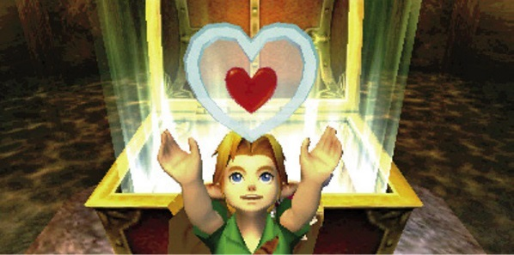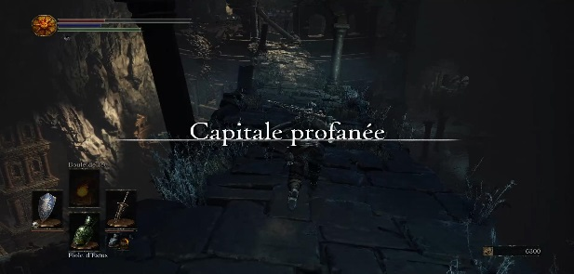

**Figure 14.** Zelda Chest. (“The Legend”).

**Figure 15.** Dark Souls Area. (“Dark Souls 3”).

**2.11 Equipment**

2.11.1 Computer Hardware

|  |  |
| --- | --- |
| **Hardware** | **Specifications** |
| Desktop Computer | PC or MAC |
| Processor (Quad-Core Intel or AMD) | 2.6 Ghz |
| RAM | 8GB |
| Graphics Card | NVIDIA GeForce 470 GTX/AMD Radeon 6870 HD |

Game engines* are the driving spirit behind video games. The most popular, and most resource taxing, game engines to use are Unreal and Unity. (“Video Game Engines”). Figure 17 below details the minimum requirements for a computer to run Unreal or Unity and will also be able to handle other engine software if need be. (*See Glossary page 20).

**Figure 16.** Hardware Requirements. (“Recommended”).

Another advantage to a computer build like this is it will also support many art design and programming applications. (“Recommended”).

2.11.2 Computer Software

Along with the hardware, operating system software is needed to use the computer and the game’s engine. There are different operating systems and development kit necessities between PC and MAC computers. See Figure 18 on page 17 for a minimum recommendation of software for PC and MAC computers.

|  |  |  |
| --- | --- | --- |
| **Model** | **Operating System** | **Additional Software** |
| PC | Windows 8.1 (64-bit) | Visual Studio, platform SDK |
| MAC | MAC OS X 10.9.4 version | Xcode 7.0 |

**Figure 17.** Software Requirements. (“Recommended”).

2.11.3 Facility

Most of the employees should share the same building but can be separated into different rooms or areas. For example, the art team could have their own room, the programmers could have a separate room, and so on. The facility should be big enough to accommodate all employees comfortably.

2.11.4 Miscellaneous

Along with room to accommodate all the employees, and enough computers for everyone to have their own workspace, the following resources might need to be allocated as needed:

* Desks and Chairs
* Tables for meetings
* Boards for diagramming and brainstorming
* Printers
* Paper
* Writing Utensils

**2.12 Marketing**

The video game industry is competitive. To grab the spotlight of investors, critics, and consumers a lot of resources must go into marketing. “With such high stakes, the effectiveness of video game marketing can make or break a new release. There are even times when the right campaign may help throw a low-budget hit into the limelight, with smash success Angry Birds a case in point.” (“Successful”).

2.12.1 Strategy

Prisoner is a standalone game with no predecessors, and as of now, no sequels. As a completely new game, the marketing strategy can’t appeal to feelings of nostalgia, which is a large part of what drove the marketing campaigns of “Rockstar’s Grand Theft Auto V” and “Bethesda’s The Elder Scrolls V: Skyrim” (“Successful”).

Considering this, potential marketing strategies could be:

* Cinematic trailers highlighting various aspects of the game
* Requesting retailers to pin up posters or set up other advertisements of the game
* Utilizing the expansive area of Social Media to appeal to a large crowd quickly (teasers through Twitter, Facebook, and Instagram might be the most effective in this area)
* Develop a beta version of the game before release to not only generate hype, but to dig up glaring flaws in code in the game

Note that marketing should only highlight only what is going to be in the game at launch. A fatal mistake would be to promise more than what the game truly offers.

2.12.2 Targeting Retailers

As the digital age grows exponentially, there is developing split between buying physical copies of videogames and digital copies of videogames. From space on shelves to space on a hard drive, and a slight price difference between the two, it seems that purchasing physical copies and digital copies comes down to personal preference (Lipshy). Figure 18 below shows data from the NPD which seems to support this:





**Figure 18.** Statistics. (“Video-Games”).

Even though this graph shows digital purchases of games with subscriptions, digital add-on content, etc., there exists an almost clean split between physical game purchases and digital purchases. Therefore, it would be most beneficial to take advantage of both brick-and-mortar retailers and online-game stores.

**Brick-and-Mortar**

* Gamestop
* Play N Trade

**Online**

* Steam
* Playstation Network
* Xbox Live

2.12.3 Social Media

Social Media allow firms to engage in timely and direct end-consumer contact at relatively low cost and higher levels of efficiency than can be achieved with more traditional communication tools. (Kaplan). Social Media is an immediate and impactful way to reach future consumers.



**Figure 19.** Social Networking. (Kallas).

Figure 19 above shows the number (in millions) of monthly visits to each social media site (Kallas). The major significance of the chart above isn’t which social media site hosts the most traffic, but rather that social media receives 5,180,000,000 monthly visits, making social media a very effective tool for marketing. However, most of the attention from marketing for Prisoner should be dedicated to the most visited social media sites: Facebook, YouTube, and Instagram.

**2.13 Cost**

2.13.2 Staffing

Figure 20 below shows the 2015 Median annual pay for the listed positions. The salaries of the lower positions (hired or approved by the upper positions) are detailed in Appendix B on page 30.

|  |  |  |
| --- | --- | --- |
| Position | Annual Salary (Median Pay in 2015) | Source |
| President | $175,110 | (“Top Executives”) |
| Chief Technical Officer | $131,600 | (“Computer”) |
| Creative Director | TBD |  |
| Art Director | $89,760 | (“Art Directors”) |
| Audio Director | TBD |  |
| Test Manager/Superviser | TBD  **Figure 20.** Salaries. |  |

# 3.0 Conclusion

**3.1 Summary**

The video game industry is experiencing a heavy negative stigma, games that almost exclusively target the multiplayer experience, and games that fail to meet the gargantuan promises of video game companies. Video games can be more than what they have become, but many developers fail to realize this.

**3.2 Recommendations**

3.2.1 Under a Stigma

The only way to break through the stigma that is currently drawn across video games is to show not only the gaming community, but the outside community that video games, even those involving violence, are and can be more than mindless ventures across unimportant, meaningless virtual landscapes. Prisoner will bring out the best in video games and expose the player to a world rich in details, as well as an emotional and impactful lesson on crime, innocence, and punishment.

3.2.2 Unfulfilled expectations

Many games come with a promise to be “the best”. Yet, very few ever live up to that promise. The goal with Prisoner is not to promise more than what it is. It’s simply a story to be told, and that story is experienced first-hand by the player. How great it becomes will depend on the player base, not the word of the developers. No promises of being “the best game ever”.

3.2.3 Casual vs competitive

Attention in the video game company needs to be drawn away from the imposing storm of competitive games and put back on the single player experience. Prisoner will open people’s eyes to the wonder of virtual storytelling. It will find its place on the shelf next to some of the big name multiplayer games and will serve as a beacon to those who seek a real and true virtual storytelling experience.

# Glossary

Game Engine - An engine is a type of software that generates source code or markup and produces elements that begin another process, allowing real-time maintenance of software requirements. (“Engine”).

Role-Playing Game(RPG) - A role-playing game (RPG) is a genre of video game where the gamer controls a fictional character (or characters) that undertakes a quest in an imaginary world. (“Role-Playing Game(RPG)”).

Single-Player - (videogame) which is played by a lone player. (“Singleplayer”).

Works Cited

“30 Most Successful Video Game Marketing Campaigns Ever.” *Best Marketing Degrees* Web. 11 Nov 2016.

“Alyx Vance.” Image. *Valve Software*. Web. 2 Nov 2016.

“Art Directors.” *Bureau of Labor Statistics.* U.S. Department of Labor. 17 Dec 2015. Web. 23 Oct 2016.

“Asgard.” Image. *Marvel Cinematic Universe.* Web. 4 Nov 2016.

“’Batman: Arkham Asylum’ Review.’” Image. *LGR Nexus*. Web. 3 Nov 2016.

“Broadcast and Sound Engineering Technicians.” *Bureau of Labor Statistics.* U.S. Department of Labor. 17 Dec 2015. Web. 23 Oct 2016.

Castro-Reyes, Joel. “Is Single Player Dying? The Move to Multiplayer and the Sacrifice of Solitude.” *Venture Beat*. 16 Jun 2014. Web. 20 Oct 2016.

“Chief Technology Officer” *Society for Human Resource Management.* SHRM. Web. 11 Nov. 2016.

“Cloud Strife.” Image. *Giant Bomb*. Web. 2 Nov 2016.

“Computer and Information Systems Managers.” *Bureau of Labor Statistics.* U.S. Department of Labor. 17 Dec 2015. Web. 23 Oct 2016.

“Computer Programmers.” *Bureau of Labor Statistics.* U.S. Department of Labor. 17 Dec 2015. Web. 23 Oct 2016.

“’Dark Souls 3’ Capitale Profanee Ds3 Soluce Walkthrough Zone Area Guide Boss Secrets.” Image. *Millennium.* Web. 2 Nov 2016.

“Engine.” *Techopedia.* Web. 10 Nov 2016.

“Ganon.” Image. *Zelda Wiki*. Web. 4 Nov 2016.

“Graphic Designers.” *Bureau of Labor Statistics.* U.S. Department of Labor. 17 Dec 2015. Web. 23 Oct 2016.

“How to Become a Computer and Information Systems Manager.” *Bureau of Labor Statistics.* U.S. Department of Labor. 17 Dec 2015. Web. 23 Oct 2016.

“Hwoarang.” Image. *Giant Bomb*. Web. 2 Nov 2016.

“Video Game Credits.” *Infogram*. Web. 13 Nov 2016.

Kallas, Priit. “Top 15 Most Popular Social Networking Sites.” Image.  *Dream Grow.* Web. 15 Nov 2016.

Kaplan, Andreas M. “Users of the World Unit! The Challenges and Opportunities of Social Media.” *ESCP Europe.* Paris, France.

Lipshy, Jarrod. “Weighing the Pros and Cons of Digital Download Vs Physical Copies.” *Unreality Mag*. Web. 13 Nov 2016.

Makuch, Eddie. “’Batman: Arkham Asylum/Arkham City’ Ps4/Xbox One Remaster.” *Gamespot*. Image. Web. 3 Nov 2016.

“Managing Creative Director” *Society for Human Resource Management.* SHRM. Web. 11 Nov. 2016.

“Multimedia Artists and Animators.” *Bureau of Labor Statistics.* U.S. Department of Labor. 17 Dec 2015. Web. 23 Oct 2016.

“Musicians and Singers.” *Bureau of Labor Statistics.* U.S. Department of Labor. 17 Dec 2015. Web. 23 Oct 2016.

Plunkett, Luke. “The Wonderful Robot Art of Elysium.” Image. *Kotaku.* 25 October 2013. Web. 20 Oct 2016.

“President & Chief Executive Officer (CEO)” *Society for Human Resource Management.* SHRM. Web. 11 Nov. 2016.

Plagge, Kallie. “’Undertale’ Review.” *IGN.* Web. 6 Nov 2016.

Purslow, Matt. “Adventures in… ‘Assassin’s Creed: Unity’ – Butcher or Benny Hill?” Image. *PC GamesN*. Web. 3 Nov 2016.

“Quality Control Inspectors.” *Bureau of Labor Statistics.* U.S. Department of Labor. 17 Dec 2015. Web. 23 Oct 2016.

“[Recommended](https://wiki.unrealengine.com/Recommended) Hardware” *Unreal Engine Wiki.* Web. 5 Nov 2016.

“Role-Playing Game(RPG).” *Techopedia.* Web. 10 Nov 2016.

Schreier, Jason. “The Stigma of Gaming: Adult Gamer.” [*Thought Catalog*](http://thoughtcatalog.com)*.* Oct 2010. Web. 10 Nov 2016.

“Sci-Fi Prison.” Image. *Deviant Art.* 23 Jan 2010.Web. 20 Oct 2016.

“Shakti Gawain: Ambition” *Brainy Quote.* Web. 20 Oct 2016.

“Singleplayer.” *Your Dictionary*. Web. 10 Nov 2016.

“Skyrim Dragon Priest Mask.” Image. *Store Envy*. Web. 5 Nov 2016.

Stewart-Seume, Bryony. “Nobody Puts Elena in a Fridge.” Image. *All Things Uncharted*. Jul 2014. Web. 2 Nov 2016.

Strom, Steven. “’Dark Souls 3’ Review Marching Towards Masochism.” Image. *Ars Technica.* Web. 5 Nov 2016.

Tassi, Paul. “It’s unclear where ‘No Man’s Sky’ Goes from Here, If Anywhere.” 2 Sep 2016. Web. 20 Oct 2016.

“’The Legend of Zelda Majora’s Mask’ 3D Chapter 11 Storming the Stone Tower Walkthrough.” Image. *Games Wiki.* Web. 7 Nov 2016.

“Top Executives.” *Bureau of Labor Statistics.* U.S. Department of Labor. 17 Dec 2015. Web. 23 Oct 2016.

“Video-Games.” *NPD.* Web. 12 Nov 2016.

“Videogames.” *Pro Con.* Web. 10 Nov 2016.

“Video Game Engines.” *Game Designing*. Web. 16 Nov 2016.

“What Art Directors Do.” *Bureau of Labor Statistics.* U.S. Department of Labor. 17 Dec 2015. Web. 23 Oct 2016.

“What Broadcast and Sound Engineering Technicians Do.” *Bureau of Labor Statistics.* U.S. Department of Labor. 17 Dec 2015. Web. 23 Oct 2016.

“What Quality Control Inspectors Do.” *Bureau of Labor Statistics.* U.S. Department of Labor. 17 Dec 2015. Web. 23 Oct 2016.

“What Top Executives Do.” *Bureau of Labor Statistics.* U.S. Department of Labor. 17 Dec 2015. Web. 23 Oct 2016*.*

Wingfield, Nick. “Esports Explosion Brings Opportunity Riches for Video Gamers.” *NYTimes.* 31 Oct 2014. Web. 20 Oct 2016.

“Writers and Authors.” *Bureau of Labor Statistics.* U.S. Department of Labor. 17 Dec 2015. Web. 23 Oct 2016.

# **Appendex A**

Appendix A-1 Sequester’s Mountain

Figure A1 shows the basic concept of the Burvingwald Penitentiary. There is an entrance to the prison that acts as a processing and identification area for inmates. The prison is built into Sequester’s Mountain and is split into multiple levels where the more severe felonies rest closer to the top and the minor felonies sit at the bottom. No level is the same and each level is overseen by its own officer. The very top is reserved for death row inmates and is where the player will begin the game.

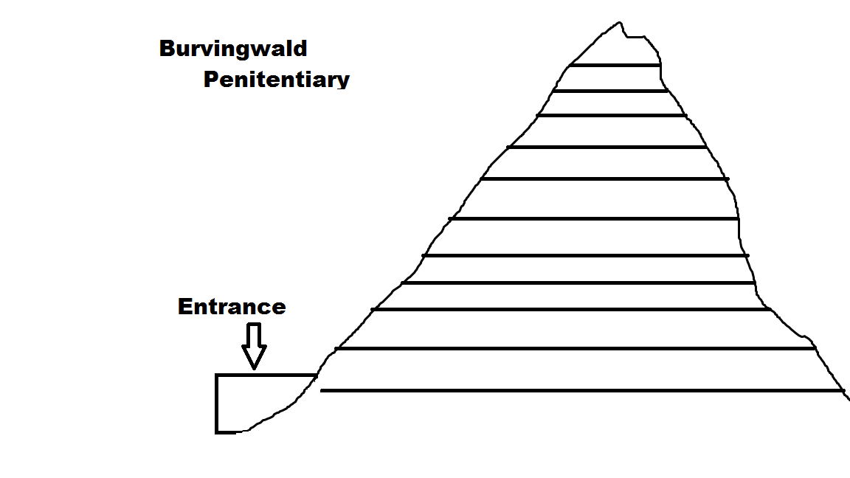

**Figure A1.** Burvingwald Penitentiary.

Appendix A-2 Death Row Containment

Figure A2 on page 20 shows the room in which Benjamin Perdix awaits his date of execution. Benjamin Perdix is surrounded by guards that restrain him if he tries to escape. The door to his prison is opened from the outside and is locked with a magic seal. His only visitors are Cecilia Griffith and Dr. Archibald Ceres.

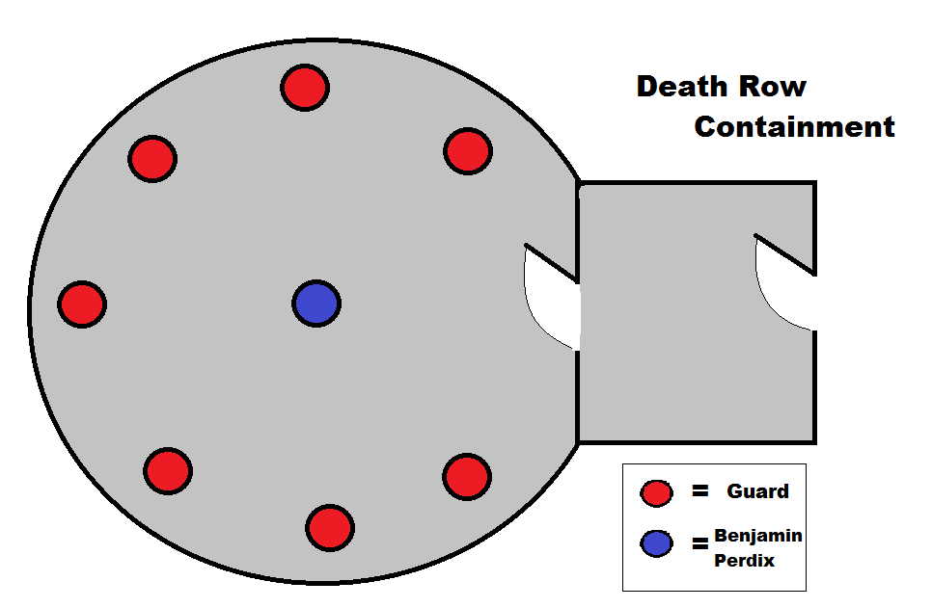

**Figure A2.** Benjamin’s Cell.

Appendix A-3 Cell Area Layout

Figure A3 depicts a small area of the prison. A level of the prison would probably be much bigger, but figure A3 simply shows the basic layout of an area with cells, mess areas and a recreational area.

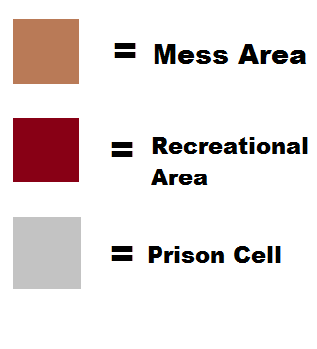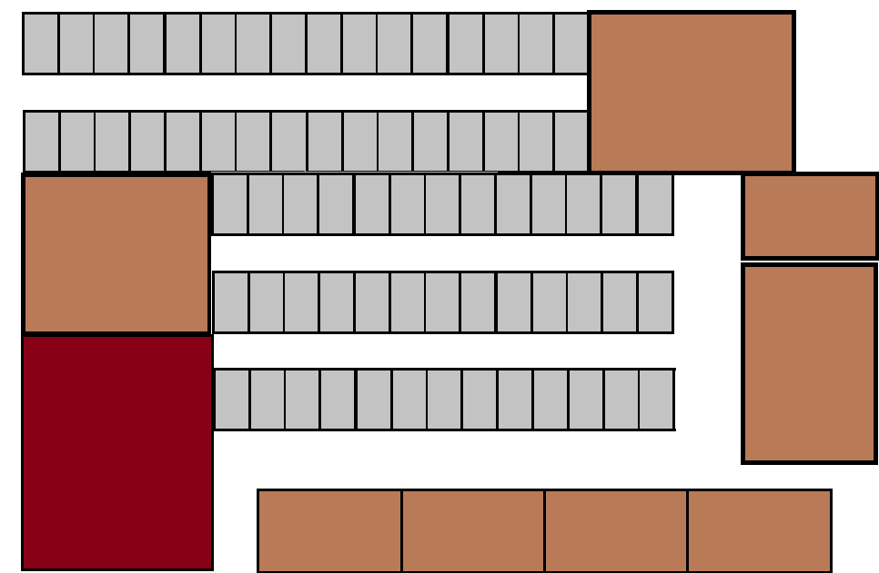

**Figure A1.** Prison Area.

**Appendix B**

Appendix B-1 Staffing Hierarchy

Figure B1 below depicts the hierarchy and chain of command that the employees should follow. Note that all positions should be conferring and communicating with each other at each step of the development process.

**Figure B1.** Hierarchy. (“Video Game Credits”).

Appendix B-2 Other Positions’ Salaries

Figure B2 below shows the salaries of the other positions that make up the army that is a video game development team. Note that some positions are merely branches of a larger field. These positions should require different or more specific qualifications, but should receive the same salary as their parent position.

|  |  |  |
| --- | --- | --- |
| Position | Salary (2015 Median) | Source |
| Artist | $63,970 | (“Multimedia Artists and Animators.”) |
| Graphic Designer | $46,900 | (“Graphic Designers.”) |
| Character Designer | (see Artist) |  |
| World Designer | (see Artist) |  |
| Animator | (see Artist) |  |
| 3D Modeler | (see Artist) |  |
| Concept Artist | (see Artist) |  |
| Sound Producer | $41,780 | (“Broadcast and Sound Engineering Technicians.”) |
| Actor | $36,200 | (“Actors.”) |
| Musician | $36,200 | (“Musicians and Singers”) |
| Foley Artist | (see Sound Producer) |  |
| Writer | $60,250 | (“Writers and Authors.”) |
| Computer Programmer | $78,530 | (“Computer Programmers.”) |
| Gameplay Mechanics Engineer | (see Computer Programmer) |  |
| Engine Programmer | (see Computer Programmer) |  |

**Figure B2.** Lower Positions.